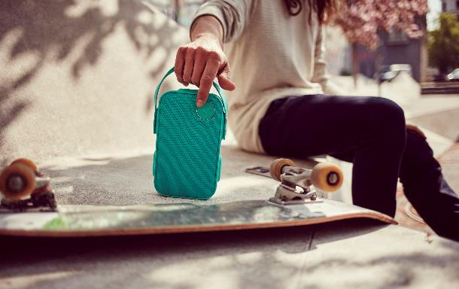
(Libratone ONE Click)

Libratone Presents ONE Click and TOO Bluetooth Portable Speakers
Easy on the Ears, Eyes and Body

Danish Design and Exceptional Acoustic Fidelity,
For People Immersed in Life Who Expect Immersive Sound

SANTA CLARA, Calif., and COPENHAGEN, Denmark, June 15, 2016: Today, Libratone introduced the ONE Click and TOO portable Bluetooth speakers, the newest additions to the family of wireless speakers featuring 360-degree premium sound created by leading acoustic and product engineers hailing from the sound capital of Copenhagen.

Unlike other portable Bluetooth speakers, Libratone’s speakers are designed with versatility in mind, coupled with exceptional sound quality. Knowing people would carry it from the beach to the campsite to the bridal shower to the barbeque, Libratone’s designers created a sleek, highly adaptable speaker that resists water – all while sporting the Danish design aesthetic that is a standard of Libratone products.

“Lugging around a thick, boxy or ball-shaped speaker is hardly liberating, especially when it has inferior sound quality,” said Libratone CEO Jan McNair. “We set out to design a portable speaker that’s versatile and adaptable, but also looks elegant, sounds spectacular, and is ergonomically minded. This was a big challenge for our acoustic team, which devised highly innovative ways to maximize not only the rich sound quality indoors but also for the outdoors, where deep bass notes and clear high tones could have been muffled or lost.”

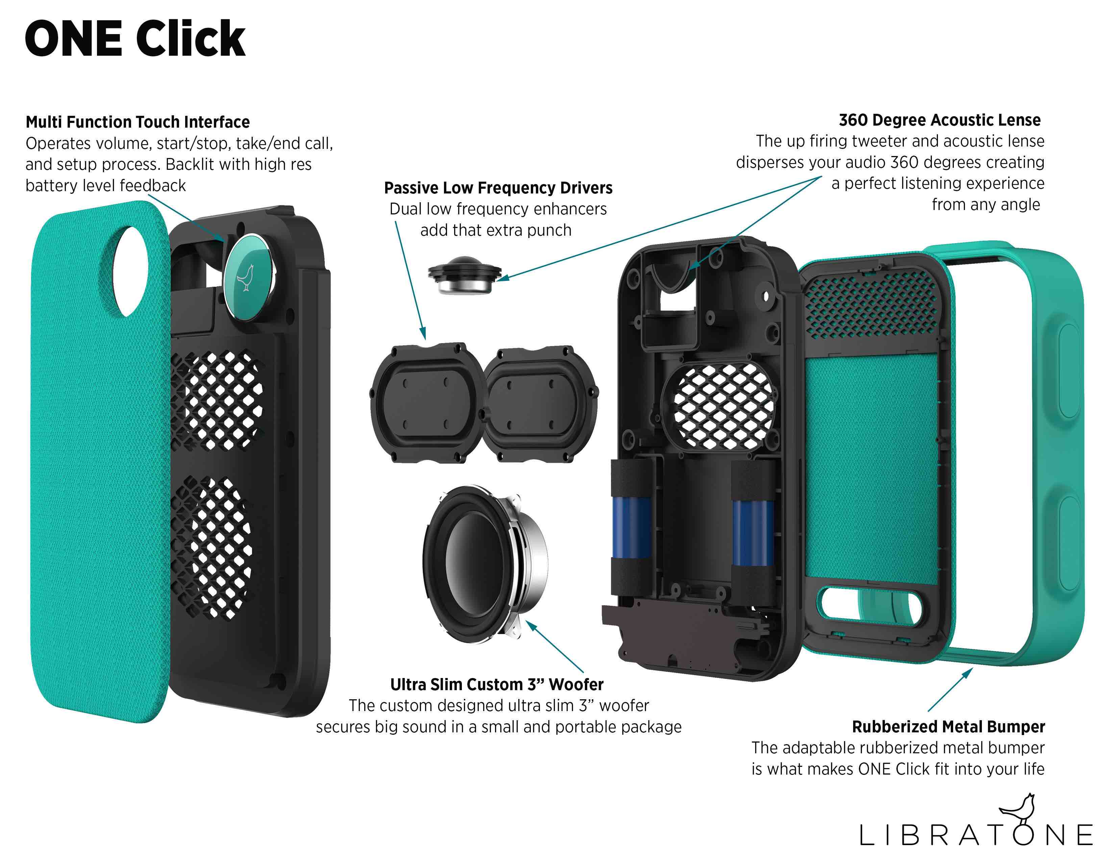

The ONE Click is about the size and shape of a paperback book and features grommets that allow it to be carried in various adaptable ways, whether clipped to a belt or slipped into a purse or backpack. Surrounded by a rubber bumper and housed in a sleek, water-resistant mesh covering, the ONE Click comes in range of colors: Graphite Grey, Caribbean Green, Cloudy Grey, and Cerise Red. The speaker comes with an adjustable short handle and a handy U-shaped lock for hanging on a bike, a tree branch, a bookshelf, or a bedframe – an optional long strap for over-the-shoulder wear will be available in August. With a click or two, users can change the way it is hung, carried or worn, never having to worry about finding a flat, level surface for setting it up.

“ONE Click adds a new level of freedom and flexibility to your music,” said Libratone President Mike Culver. “Great music sets the stage for life’s memorable moments, no matter where you go, no matter what you are doing. We designed ONE Click to adapt to any location or scenario, for the person whose life is in motion.” ONE Click’s dimensions: 4.7 x 1.6 x 8.1 inches; weight: 2 lbs.

The TOO is the playful, portable speaker with big sound packed into a convenient, diminutive grab-and-go package. Shaped like an overstuffed hot dog, the TOO fits easily into a bag or back pocket – as long as you’re not wearing skinny jeans – and comes in the same color palette as the ONE Click. TOO’s dimensions: 8.3 x 2.6 x 2.3 inches; weight: 1.3 lbs.

(Libratone TOO)

Like all Libratone speakers, ONE Click and TOO are specifically tuned to provide a full range of sound without compromise – from the deep bass, to full midrange and crisp treble – so they sound great, whether playing Miles Davis or Miley Cyrus. Along with audio indicative of the Danish acoustic engineering tradition, they are created with the aesthetics of Copenhagen’s design character, which is known for minimalism and timeless elegance combined with thoughtful functional purpose. The end result is fidelity, flexibility and fashion all co-existing in single, smart package.

The ONE Click and TOO feature 360-degree sound, projecting audio in every direction. Wherever the speaker is placed, everyone has an equally clear, direct acoustic experience, without having to deal with the compromised sound of a traditional one-sided speaker pointed in the wrong direction. Battery life is more than 12 hours and the speakers can be controlled and linked via the Libratone app for iOS and Android. The speakers include a touch interface and feature Bluetooth 4.1, and Bluetooth +1 technology, which means you can pair two of them together from the app for a fuller, even more immersive sound.

The ONE Click and TOO speakers come with a money back “no questions asked” return policy because Libratone knows you want to hear the speakers in real life. Simply buy the speakers at www.libratone.com and try them out for 30 days. A pre-paid return label is included in the box, so if you’re unsatisfied, you can ship it back. Shipping is free both ways.

The ONE Click is available now for $199; the TOO will be available on July 1 for $149.

- ENDS -

For more information please contact:
Mark de la Vina
Consort Partners for Libratone
libratone@consortpartners.com
415-282-4795

About Libratone
Founded in 2009 in Copenhagen, Denmark, Libratone was launched by sound and design engineers hailing from the esteemed likes of Bang & Olufsen and Bower & Wilkins, with a focus on blending the best in Scandinavian design with innovative, wireless acoustic technology products for consumers who enjoy music on the go. Libratone specializes in high-performance audio speakers that deliver a warm, deeply immersive listening experience, whether indoors or out.

Press materials can be found at: www.libratone.com/press
Facebook: www.facebook.com/Libratone
www: libratone.com
Twitter: @Libratone
Instagram: @Libratone
Shop: libratone.com

